**RFID CONTROLLED AUTOMATED PATH ROBOT**

**OBJECTIVE:**

The primary objective of this project is to develop a sophisticated robotic system that utilizes RFID (Radio-Frequency Identification) technology to autonomously navigate predefined paths. By integrating RFID readers and tags, the project aims to demonstrate precise control and navigation of a robot, enhancing its ability to follow designated routes accurately and efficiently.

**ABSTRACT:**

The project focuses on implementing RFID technology to enable precise control over a robotic system's movements. RFID readers strategically positioned along predefined paths communicate with RFID tags embedded within the robot, facilitating real-time communication and guidance. This integration offers a novel approach to navigation, enabling the robot to navigate complex terrains or designated paths without human intervention.

**INTRODUCTION:**

In today's technological landscape, autonomous navigation is a critical aspect of various industries, including manufacturing, logistics, and smart infrastructure. The use of RFID technology presents a promising solution for precise and efficient path control in robotics. This project delves into the development of a robotic system that leverages RFID readers and tags to navigate predefined paths accurately. By incorporating RFID technology, the system gains the capability to identify and interpret RFID tags placed strategically along the intended route. This communication allows the robot to adjust its movements, follow specified paths, and potentially make decisions based on the information received from the RFID tags. The integration of RFID-controlled navigation holds significant promise for applications requiring automated and controlled movement, such as warehouse management, transportation, and surveillance. This project aims to explore the feasibility and effectiveness of RFID technology in enhancing the autonomy and precision of robotic navigation systems. Through this endeavor, we aim to showcase the potential of RFID-based control systems in robotics, offering an innovative and efficient approach to autonomous path navigation for various practical applications.

**EXISTING SYSTEM:**

The existing system automated path control for robots primarily relied on traditional methods such as pre-programmed routes, sensors like proximity detectors, and computer vision systems for navigation. These systems often faced limitations in adaptability and real-time adjustments. Pre-programmed routes restricted the robot's flexibility, while proximity detectors lacked the granularity for precise path control. Computer vision systems struggled in complex environments with varying lighting conditions and obstacles. The absence of robust real-time control mechanisms hindered the agility and adaptability required for dynamic environments. This limitation in precision and adaptability underscored the need for a more sophisticated and responsive navigation system, which led to the exploration of RFID technology to enhance the control and flexibility of automated path robots.

**DISADVANTAGES:**

1. Limited Adaptability
2. Lack of Precision
3. Environmental Dependency
4. Complexity in Real-Time Adjustments
5. Cost and Maintenance
6. Limited Interactivity
7. Sensitivity to Interference

**PROPOSED SYSTEM:**

The proposed system for the project integrates RFID readers strategically positioned along designated paths. RFID tags embedded within the robot communicate with these readers, enabling real-time data exchange for precise navigation. This system facilitates dynamic path

adjustments based on RFID tag recognition, allowing the robot to follow predefined routes accurately. The RFID technology provides granular control, enhancing the robot's adaptability in complex environments. It aims to offer a responsive, autonomous navigation system capable of interpreting RFID tags to make informed decisions, ensuring efficient and accurate path traversal without the limitations of traditional pre-programmed routes or sensor-based navigation systems.

**ADVANTAGES:**

1. Precision in Navigation
2. Real-time Adaptability
3. Reduced Dependency on Environment
4. Enhanced Flexibility
5. Improved Efficiency
6. Lower Maintenance Requirements
7. Enhanced Interactivity
8. Reliability and Consistency

**BLOCK DIAGRAM (HARDWARE):**

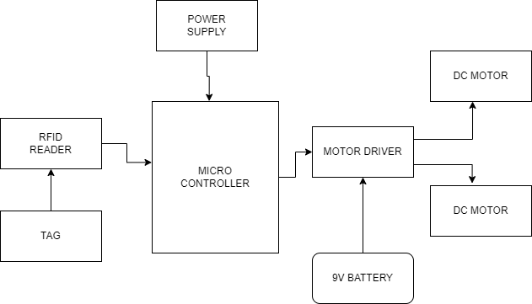

**SOFTWARE REQUIREMENTS:**

* Arduino ide
* Embedded C

**HARDWARE REQUIREMENTS:**

* Microcontroller
* RFID Reader & Tag
* Motor driver
* Dc motor
* 9V Battery

**CONCLUSION:**  
In conclusion, the integration of RFID technology into automated path control for robots showcases a significant leap forward in precision navigation. The system's ability to interpret RFID tags allows for dynamic adjustments and enhanced adaptability in traversing predefined routes. This innovation holds promise across industries, offering reliable and efficient autonomous navigation in complex environments. The project demonstrates the potential for RFID-based systems to revolutionize robotics by providing real-time, granular control over path-following mechanisms. As a versatile and responsive solution, this technology promises increased efficiency, reduced maintenance, and improved adaptability, paving the way for future advancements in autonomous robotics and diverse applications.

**REFERENCE:**

[1] W. Hou, Z. Xiong, C. Wang, and H. Chen, ‘‘Enhanced ant colony

algorithm with communication mechanism for mobile robot path planning,’’ Robot. Auto. Syst., vol. 148, Feb. 2022, Art. no. 103949, doi:

10.1016/j.robot.2021.103949.

[2] M. Zhao, H. Lu, S. Yang, and F. Guo, ‘‘The experience-memory Q-learning

algorithm for robot path planning in unknown environment,’’ IEEE Access,

vol. 8, pp. 47824–47844, 2020, doi: 10.1109/ACCESS.2020.2978077.

[3] J. Zhao, S. Liu, and J. Li, ‘‘Research and implementation of autonomous

navigation for mobile robots based on SLAM algorithm under ROS,’’

Sensors, vol. 22, no. 11, p. 4172, May 2022, doi: 10.3390/s22114172.

[4] L. Liu, B. Wang, and H. Xu, ‘‘Research on path-planning algorithm

integrating optimization A-star algorithm and artificial potential field

method,’’ Electronics, vol. 11, no. 22, p. 3660, Nov. 2022, doi:

10.3390/electronics11223660.

[5] S. Wang, Z. Ren, and M. Wu, ‘‘Non-uniform input-based adaptive growing

neural gas for unstructured environment map construction,’’ Appl. Sci.,

vol. 12, no. 12, p. 6110, Jun. 2022, doi: 10.3390/app12126110.